**What is CSS?**

CSS (Cascading Style Sheet) is basically used to style everything used in an HTML webpage/ website.

To connect a CSS file to an HTML file we use the ***<link>*** element within the HTML file.

* A ***rel=”stylesheet”*** attribute is used within the ***<link>*** element to specify we linking to a stylesheet.
* A ***href=”name of stylesheet”*** attribute is used within the ***<link>*** element to specify the actual name of the stylesheet being referenced.

To write code in CSS we need to know two things, the ***selector*** and ***declaration***.

* Selector contains the declaration as shown below, the ***body {}*** being the selector and ***height: 100%; width: 100%*;** being the declaration.

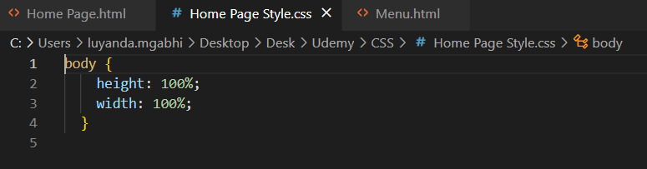

* We specify the element we want to change, i.e. <head>, <body>, etc. and within curly braces {} put in the different styling we want to appear on that element portion.

To comment on CSS code, ***/*--comment */*** is used.

Element id can also be used within CSS files to reference HTML elements:

* For example instead of specifying an ***<h1></h1>*** element in CSS file, you can go into the HTML file and specify an id within the opening tag of the <h1> element as follows; ***<h1 id=”welcomeHeader”>*** then go back to CSS file and use ***#idname(welcomeHeader)*** as your selector.
* By using the ***#*** sign the CSS file will know you’re trying to call an element id.

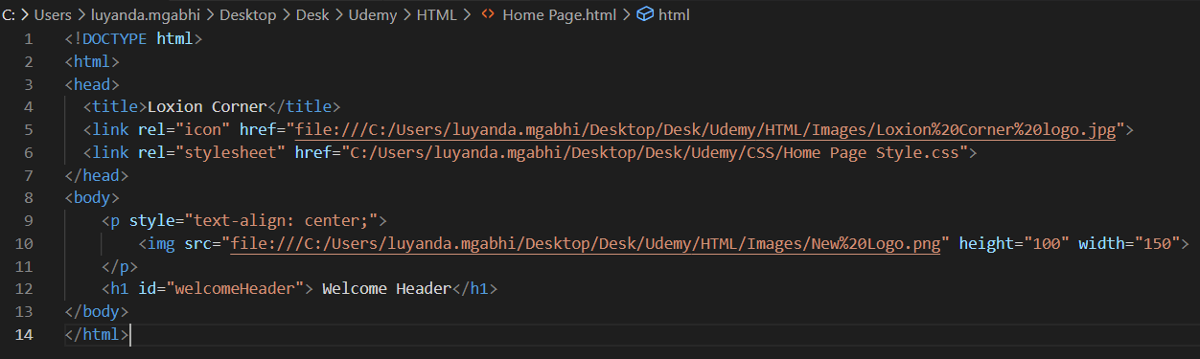

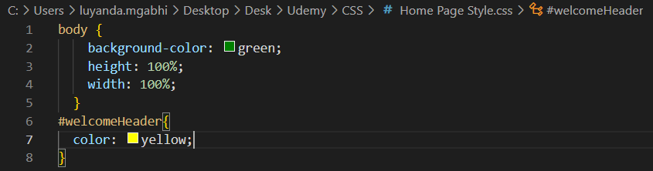

* The ***id*** attribute can be used in any HTML element.
* One use case of the id use in CSS is when you have two <h1> elements and you only want to style one of them, the id attribute comes in handy or else if your CSS select is not specified as an id, all similar <h1> elements will have the same styling effect.

Another way of selecting certain HTML elements to style in CSS is by using ***classes***, which is an alternative to using CSS ***ids.***

* The ***class=””*** attribute works the same as id attribute for CSS but uses the ***.classname (heading2)*** or full stop sign as opposed to using ***#*** sign for ids.

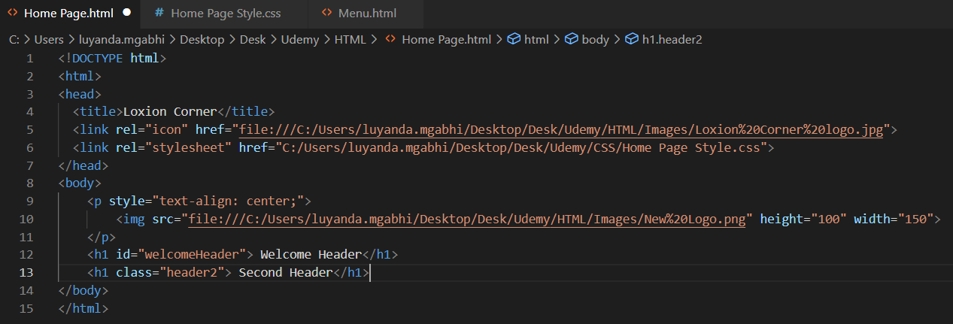

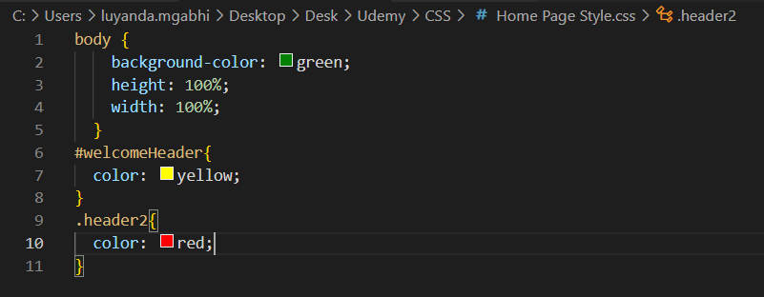



If you want everything to be affected by the styling, then you use the ***universal selector (*).***

You can also make use of the ***grouping selector*** to declare the same CSS styling for two different HTML elements as follows; ***h1, p1{ color: green;}***

To add a background image in CSS file, the ***background–image: ur(“image file path”);*** declaration is used.

To avoid the issue of the image repeating itself when displaying on webpage, we need to set the following declarations within the body selector

* ***background-repeat: no-repeat;***
* ***background-attachment: fixed;***
* ***background-size: 100% 100%;***